Software Requirements Specification

**Equipment Reservation System(ERS)**

Version 1.1

20/01/2015

Prepared for :

IITI - CS 208 - Software Engineering

Spring 2015

Under the Guidance of: Dr. Abhishek Srivastav

Development Team:

Hursh Tiwari

Anant Lal

Manish Singh Saini

Simmi Malhan

**Table of Contents**

Revision History 2

Document Approval 3

1. Introduction 4

1.1 Purpose 4

1.2 Scope 4

1.3 Definitions, Acronyms, and Abbreviations 5

1.4 References 5

1.5 Overview 5

2. General Description ii

2.1 Product Perspective 6

2.2 Product Functions 6

2.3 User Characteristics 6

2.4 General Constraints 6

3. Specific Requirements ii

3.1 External Interface Requirements 7

3.1.1 User Interfaces 7

3.2 Software Requirements 13

3.3 Functional Requirements 14

3.4 Logical Database Requirements 22

A. Appendices 23

A.1 ER diagram 23

A.2 Use case diagram 24

# Revision History

|  |  |  |  |
| --- | --- | --- | --- |
| **DATE** | **DESCRIPTION** | **AUTHOR** | **COMMENTS** |
| 20/01/2015 | 1St fully completed version of srs with basic structure complete | * Manish Singh Saini * Hursh Tiwari * Simmi Malhan * Anant Lal | Only addition of images and sr diagram left. |
| 22/01/2015 | Final draft completed. | * Manish Singh Saini * Hursh Tiwari * Simmi Malhan * Anant Lal | - |
|  |  |  |  |
|  |  |  |  |

# Document Approval

The following Software Requirements Specification has been accepted and approved by the following:

|  |  |  |  |
| --- | --- | --- | --- |
| **SIGNATURE** | **PRINTED NAME** | **TITLE** | **DATE** |
|  | Dr. Abhishek Srivastava | Instructor-CS 208 |  |
|  | Dr Vipul Singh | Final Client |  |
|  | Anant Lal | Developer |  |
|  | Hursh Tiwari | Developer |  |
|  | Manish Singh Saini | Developer |  |
|  | Simmi Malhan | Developer |  |

**INTRODUCTION**

**PURPOSE**

The current system is the discipline of Electrical Engineering IIT-Indore for usage of equipments in heavy-duty research lacks order and does not guarantee any safeguards as to catch a culprit in case a machine failure occurs.

Through our software the ERS we would create a system through which the user can book usage of a particular equipment prior to actually using it. Such a software would ensure smooth functioning of research labs as well as allow authorities to identify a wrong-doer in case a machine failure does occur.

The current document is intended to serve as a final design guideline to the development team. For the end-user this document shall provide complete description of the end-product.

Though a great many efforts have been put forward in creating this document, the developers realize that the document may contain certain functionality that the developers might not be able to provide as described. At the same time the developers also realize that if they fail to do so they would certainly try to accomplish the task via another method. In such a case developers take full responsibility of their actions and would duly let the end-user know of such changes.

**SCOPE OF THE PROJECT**

Though this project is currently being pursued only for the thin film characterization lab of the Electrical Engineering Department, if successful, the project can be extended as a reservation system for the SIC facility of IIT- Indore.

The current version will support the functionalities of booking and cancellation of usage of particular equipments by all. Also the current version shall allow Admin to implement searching for users, equipments. In the current version the Admin shall

be able to review history of equipment usage for at least a mont

Using the ERS requires compulsory internet connection. The users would have to go to a specific URL in order to login to their respective pages. A database is maintained to keep the user record and to manage the date and day bookings.

**DEFINITIONS AND ACRONYMS**

|  |  |
| --- | --- |
| **WORD** | **DESCRIPTION/EXPANSION** |
| ADMIN/admin | The administrator is the person who has all privileges regarding the handling of software. |
| DESC | Description |
| DEP | Dependency |

**REFERENCES**

1. IEEE Software Engineering Standards Committee, “IEEE Std 830-1998, IEEE Recommended Practice for Software Requirements Specifications”, October 20, 1998.
2. SRS for "Amazing Lunch Indicator" by students from Chalmers University Of Technology, Sweden.

**OVERVIEW**

The rest of the document is divided into three segments. The first segment provides the overall description of the proposed system. In this segment the general guidelines for development of the system are provided. The intended users are also described in this section. The second segment contains the overall system requirements and the detailed functional requirements. The developers will follow these specifications while developing the end product. The third chapter holds the appendix section where numerous diagrams have been specified for aid in understanding the intended end product. An index has also been provided in this section.

**GENERAL DESCRIPTION**

**PRODUCT PERSPECTIVE**

The ERS consists of a web application that provides the users with an interface on which they can book the date and time for using particular equipments.

**PRODUCT FUNCTIONS**

* The administrator for the web application shall add accounts of new users for the laboratory.
* The administrator can add equipment details if new equipments are added to the lab.
* The administrator shall be able to see all records of the current users.
* The administrator can also add other administrator.
* The administrator also can delete users and administrators.
* All Users have password protected pages where they can do their own bookings.
* All Users can edit their profiles.
* All Users can cancel their reservations for equipments.

**USER CHARACTERISTICS**

The end – users are broadly categorized into users and admins:

1. ADMIN: The admin holds all authority of the end product. He is granted all the privileges in using the product.
2. USERS: These are the people who will be using the ERS for booking purposes. Their access over the end product will be limited.

**GENERAL CONSTRAINTS**

* The Internet connection is a constraint for the application since the application fetches data from a database over the Internet.
* The application is hosted on a server so the server capabilities also constrain the functioning of the application.
* The application is constrained by the capacity of the database. When multiple users will be booking equipments, the database will take time to fetch the data.
* A constraint on booking lies that a user cannot book an equipment for more than twenty-four hours. If such a need arises the user will have to make two bookings.
* A user cannot book two equipments simultaneously for a given time slot.
* If the equipment is previously booked or the time of booking clashes with another booked time the user is not allowed to make such a booking.

**SPECIFIC REQUIREMENTS**

**External Requirements:**

This section provides a detailed description of all inputs into and outputs from the system. It provides the basic prototypes of the user interface.

**User Interface**

* 1. ADMINISTRATOR(admin)
     + 1. On typing in the URL the admin is directed to the main page of the website.
       2. He can go to the login page from the main page via the login button.
       3. Here he has can access his account by entering his username and password.
       4. In the main admin page the user is presented with a list of equipments. Clicking on a particular equipment brings up a calendar view for the particular equipment. On clicking a particular date on the calendar the page displays a chart for the particular day and the particular equipment. Here the admin can book the equipment for a particular time slot.

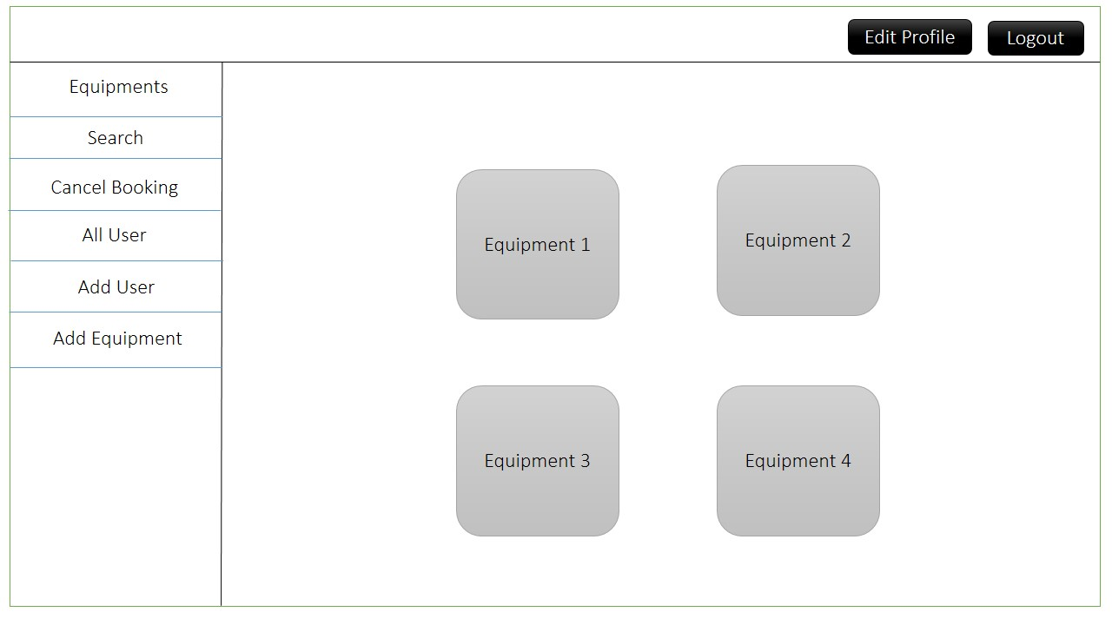

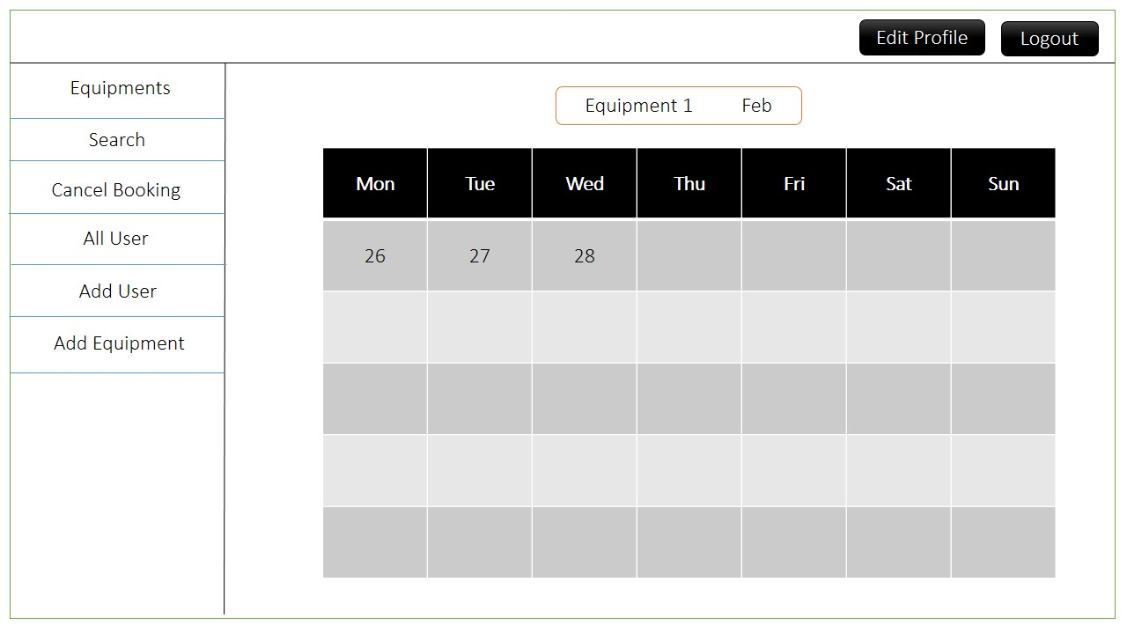

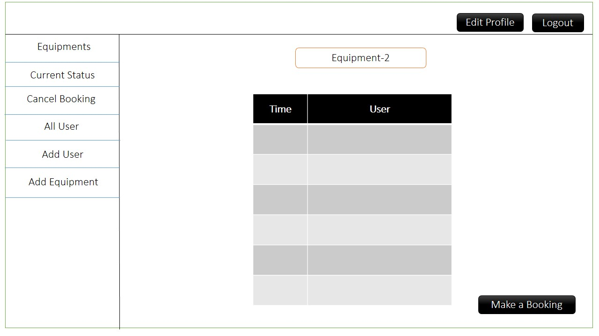

* + - 1. On the main admin page the admin can edit his own profile.

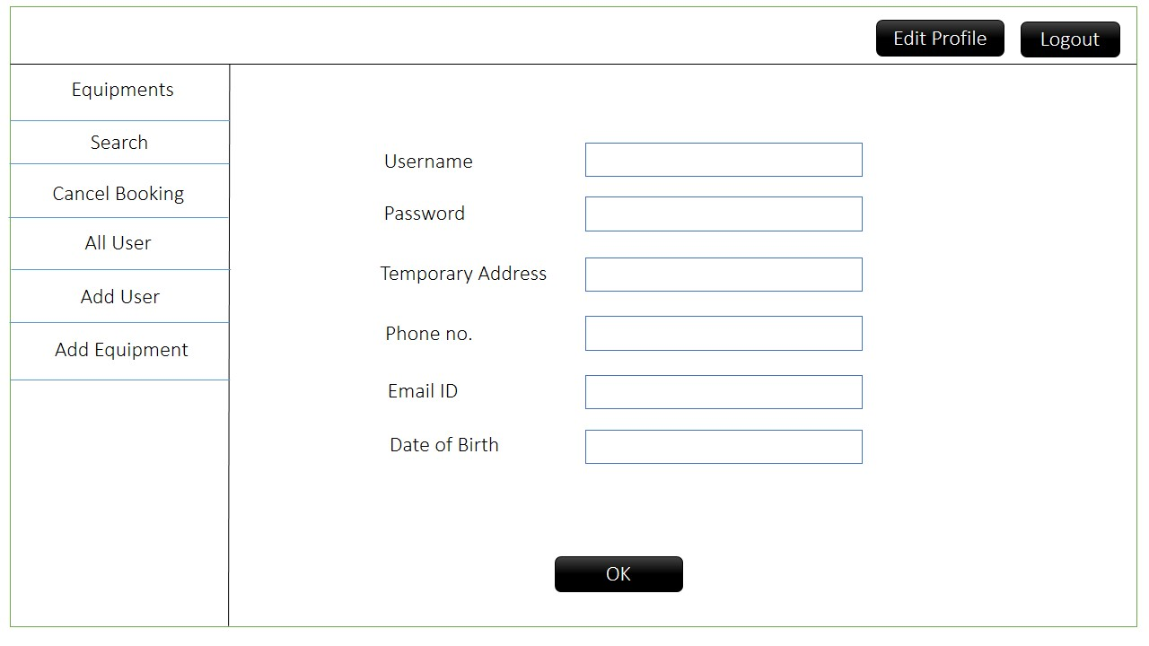

* + - 1. On the main page links are provided that allow the admin to
         1. Add a new user

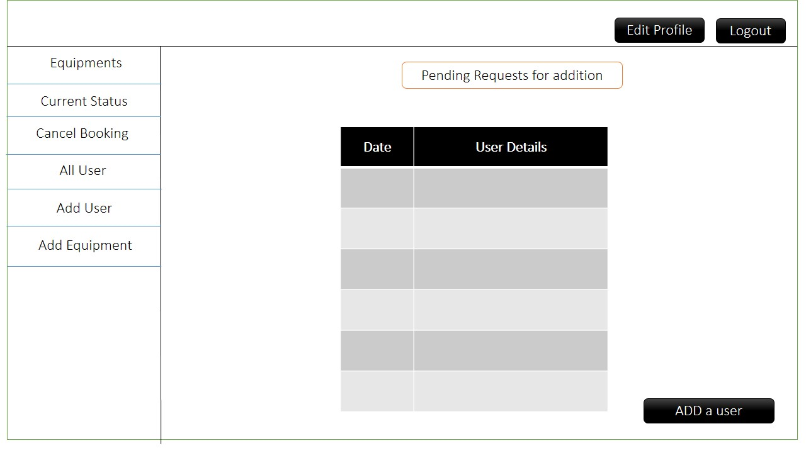

* + - * 1. Add a new equipment

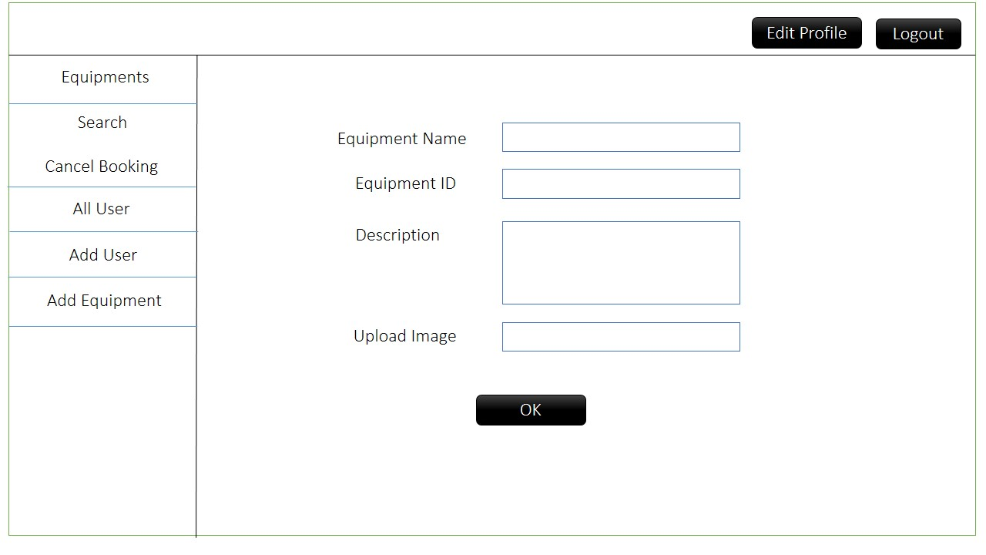

* + - * 1. Delete a current user
        2. Remove a current reservation over a particular equipment.(cancel booking)
        3. View history for a particular equipment(search)
  1. USERS:
     + 1. The user can access the main page of the website.
       2. He can go to the login page from the main page.
       3. Here he has can access his account by entering his username and password.

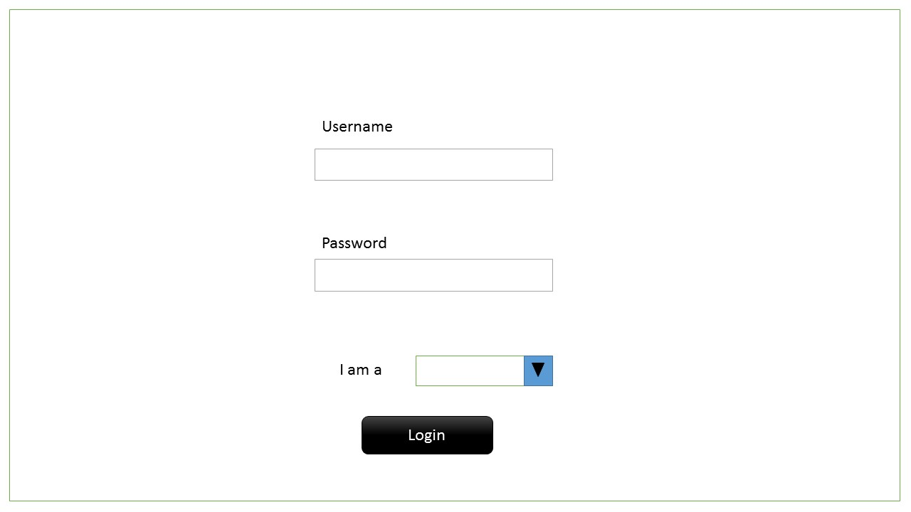

* + - 1. 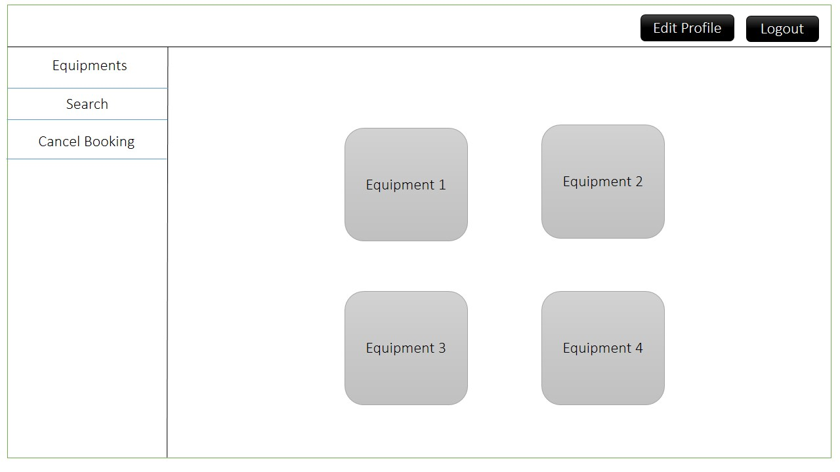In the main admin page the user is presented with a list of equipments. Clicking on particular equipment brings up a calendar view for the particular equipment. On clicking a particular date on the calendar the page displays a chart for the particular day and the particular equipment. Here the user can book the equipment for a particular time slot.

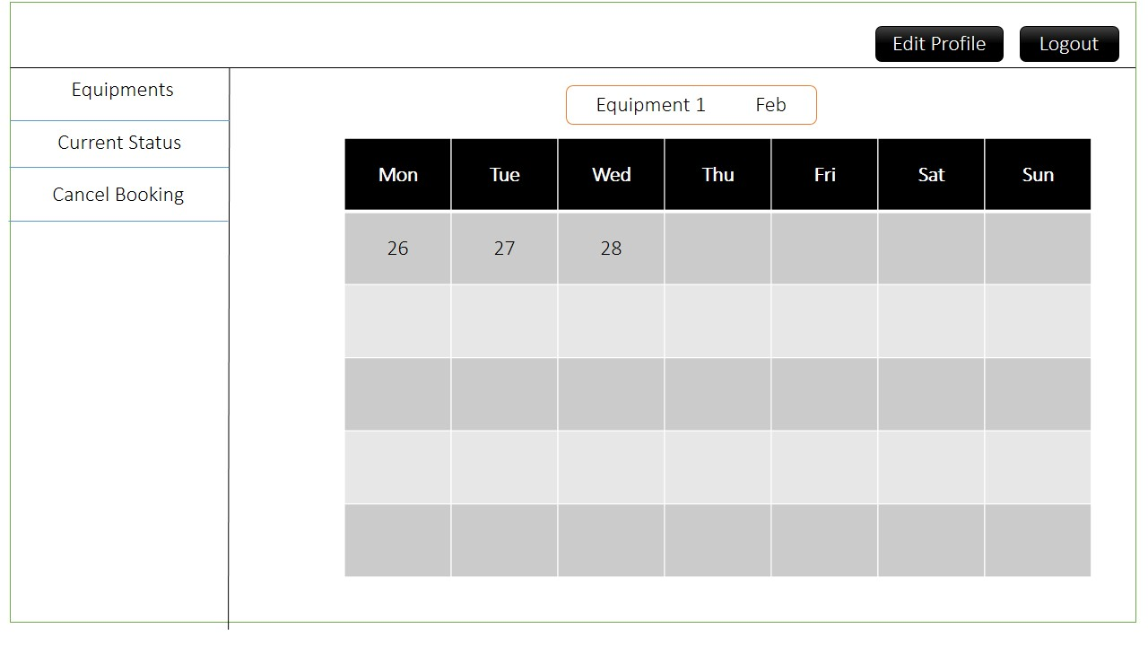

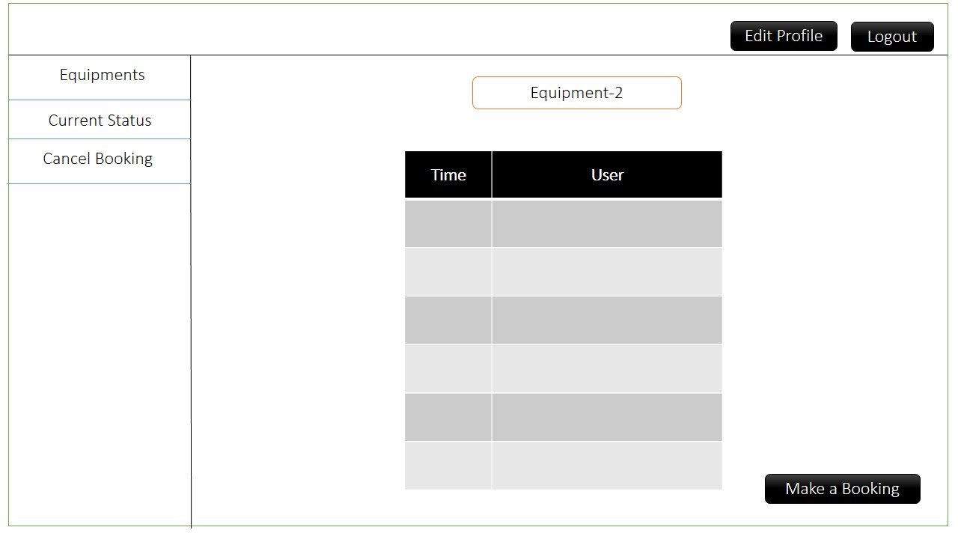

* + - 1. On the main user page the user can edit his own profile.

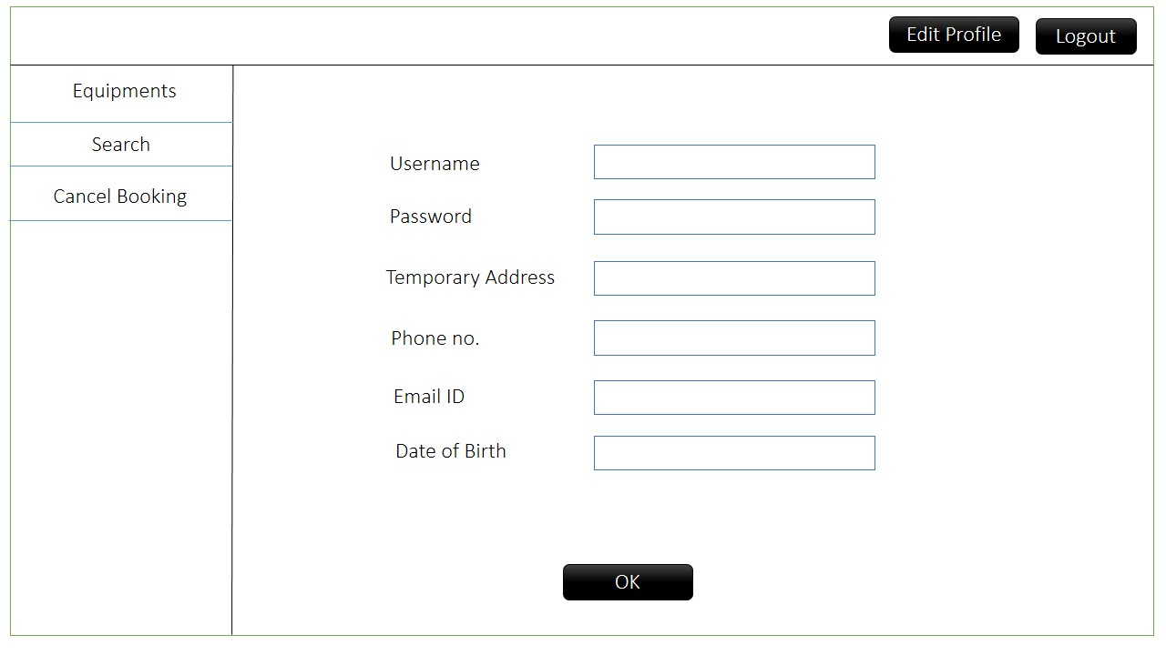

* + - 1. On the main page links are provided that allow the user to
         1. Remove a current reservation over a particular equipment (cancel booking).
         2. View history for a particular equipment (search).

**Software Requirements**

The web application and the database are the only two components used in this project. The web application is used to both read and write the data on to the database. Therefore the only major software requirements would be efficient handling of reading and writing of data onto database and implementing proper security features.

**Functional Requirements**

1. **ADMIN LOGIN**

**1.**

TITLE: Accessing the login page

DESC: Given that the admin is on the main web page, there shall be a login button on this page. Clicking on the login button takes the admin to the main login page.

DEP: none;

**2.**

TITLE: Logging in

DESC: On the main login page the admin has to input his username, password, and from a checklist select that he is the admin. There shall be an ‘OK’ button on this page to enable logging in.

DEP: **1.**

**3.**

TITLE: Verification of Credentials following Log In

DESC: After the admin has entered the username, password and clicked the OK button, all the entered data will be sent to the database to check the credentials for correctness.

If they are incorrect the user shall be prompted on the same login page that the username and password are incorrect. Else if the input is correct then the admin shall be directed to his respective main page.

DEP: **2.**

1. **USER REGISTRATION**

**1.**

TITLE: Accessing the registration page

DESC: The user shall have to navigate to the URL of the web application. On the main page the user shall be able to click on a button called ‘REGISTER’. This will direct the user to the registration page.

DEP: none;

**2.**

TITLE: Registration Page

DESC: The registration page will consist of the fields’ username, name, password, email, temp address, permanent address and contact no. There will be an OK button clicking on which, the details are sent to the admin so that he can add the user.

DEP: **1.**

**3.**

TITLE: Post Registration

DESC: After registration the admin shall have the responsibility to add the new user. For doing this the admin will have to access the 'ADD USER' page whose link will be present on the admin's main page. On the add user page the pending addition requests shall be displayed in tabular form. To add a particular user the admin shall have to click on the add user button next to the user's information.

DEP: **2.**

**4.**

TITLE: Database usage for User addition.

DESC: When a user adds a request for adding him/her as a user the request is stored in a table temporarily. When the admin adds this user the information from the temporary table is added to the permanent users table. If the admin decides not to allow the user an account the data is deleted from the temporary table. If for some reason the user forgets to add the new user for more than 10 days. The data from the temporary table is deleted and then the user would have to re-register.

DEP: **3.**

1. **USER LOGIN**

**1.**

TITLE: Accessing the login page

DESC: Given that the admin is on the main web page, there shall be a login button on this page. Clicking on the login button takes the admin to the main login page.

DEP: none;

**2.**

TITLE: Logging In

DESC: If the user is registered, he can login using his “username” and “password”. The user then has to press the OK button to send the information for verification and the subsequent login

DEP: **1.**

**3.**

TITLE: Verification of Credentials following Log In

DESC: After the user has entered the username, password and clicked the OK button, all the entered data will be sent to the database to check the credentials for correctness.

If they are incorrect the user shall be prompted on the same login page that the username and password are incorrect. Else if the input is correct then the user shall be directed to his respective main page.

DEP: **2.**

1. **PROFILE MANAGEMENT**

**1.**

TITLE: Accessing the Edit Profile page.

DESC: Once the user is logged in the user shall be able to access the edit profile page by clicking on the edit-profile button on the user’s main page.

DEP: None;

**2.**

TITLE: Edit UserId, Username, Email, Contact No., Temporary Address, Permanent Address, Photo.

DESC: On the edit profile page the user shall be displayed his current profiles details. These will be fetched from the database. The user can then modify these details and click on the ‘submit’ button to complete the process.

On submitting the details shall over write the previous given details in the database. If there is some error in writing an error will be displayed. If the transaction is successful the user shall be redirected to his main page and a dismiss-able notification shall be shown telling that the users profile has been successfully edited.

DEP: **1.**

1. **RESERVATION PROCESSES AND CASES**

**1.**

TITLE: Checking availability status of lab equipment in a month.

DESC : Given that the user is present on the ‘equipments’ page, he/she should be able to check the status of free slots of an equipment on various days of the current month by clicking on that particular equipment photo on the current page. Clicking on it should take the user to a ‘calendar view’ of the current month displaying all the day and dates. The three colours of the dates should represent three different statuses-

RED – All slots of the date are booked.

YELLOW – Some of the slots are free.

GREEN – All slots are free.

All the dates are active links hovering on which the colour of the dates should fade out. This also means that reservation can be done at any day of the month.

DEP: none;

**2.**

TITLE: Booking a particular lab equipment

On the calendar view for particular equipment, clicking on any of the date should take the user to a page displaying the ‘booked time slot’ view of that particular date. The user should be able to see all the ‘booked’ slots of that date in a list format. Each slot should have a value in the front of it-‘Name of the person who booked it’.

On the ‘booked slot list’ page, there shall be a button telling user that to ‘make a booking’ if he wants to. On clicking this button there shall pop up a ‘reservation box’ to let the user book the slot within the free time period by choosing the ‘start-time’ and ‘end-time’ from the drop-down list available in front of each field. The start time and end time can be any time of the day (00:00 A.M to 00:00 P.M).The reservation box also needs the user’s password again. There are two buttons in this box one to ‘proceed’ with making the booking, another to ‘cancel’ this state and return to the list view. A close button is also provided which serves the same purpose as ‘cancel’.

DEP: none;

**3.**

TITLE: Choosing a time period which is not present in ‘free slot time periods’ of a day.

DESC: Given that the user is present on ‘reservation column’ on the page containing ‘booked time slot’ view of a date, if he chooses start time and end time in such a way that it intersects with any of the already ‘booked time slot’ or in other words if the time period chosen doesn’t belong to the ‘free slot time periods’, then after the user clicks on ‘PROCEED’ in hope of reserving equipment, the software should open a pop-up indicating the user that ‘the entered time slot isn’t available, please see the ‘free slot time periods’’. The pop-up should have an OK button clicking on which the user can again see the earlier view containing ‘reservation column’ along with other details.

DEP: **2.**

**4.**

TITLE: Two users choosing the ‘free time slots’, which intersect, of the same date concurrently.

DESC: Given that the two users are present on ‘reservation column’ view of a same date on their respective systems and if one of them chooses a free slot at a time when the other one is already dealing with a free time slot that intersects with that of the former one, then the software should display a pop-up telling the former user that ‘the reservation can’t be done at the instant, please try a few minutes later’. In case both of them choose the free slots, that intersect, concurrently, then the same pop-up will be shown to both the users. The pop-up should have an OK button clicking on which the user can again see the ‘reservation column’ view.

DEP: **2.**

**5.**

TITLE: A user choosing a ‘free time slot’ that intersects with one of his ‘booked time slots’ for some other equipment on the same date.

DESC: Given that the user is present on ‘reservation column’ view of a date, if he chooses a ‘free time slot’ that intersects with one of his ‘booked time slot’ for some other equipment of the same date, then after user clicks ‘PROCEED’, then the software should display a pop-up telling the user that ‘the reservation can’t be done as you have already booked an equipment in related time slot’. The pop-up should have an OK button clicking on which the user can again see the ‘reservation column’ view.

DEP: **2.**

**6.**

TITLE: User choosing a ‘free time slot’ which **doesn’t** intersect with the-

1. ‘Free time slot’ chosen by any other user on his system at the same instant.
2. ‘Booked time slot’ of the same user on the same date for any other equipment.

DESC: Given that the user is present on ‘reservation column’ view of a date, if he chooses a ‘free time slot’ by entering ‘start time’ and ‘end time’ and clicks on ‘PROCEED’ button, he should be shown a ‘modal’ asking him various details required for the reservation. This includes username, password, and email-id and contact number. The start time and end time of the slot should be filled automatically depending upon the time slot chosen earlier. Now, the user can complete the reservation process by clicking on the ‘RESERVE’ button which prompts the user about ‘reservation success’ page.

DEP: **2.**

**7.**

TITLE: Reservation success page.

DESC: Given that the user has successfully booked a free slot from the ‘reservation column’ view of a date through a ‘modal’, he should be shown a ‘reservation success’ page. It should show the user that he/she has successfully reserved the slot on that particular date along with the details of the reservation that is- time slot booked, date for which it is booked and date of booking.

Also, the page should show the link to the ‘calendar view’ of the same equipment(for doing another reservation/ checking availability status), link to the ‘equipments’ page and a link to the ‘home’ page.

//Also, on successful reservation, a message should be sent to the user’s contact number (entered on modal) as well as email-id (entered on modal) which will include time slot booked, date for which it is booked and date of booking. This phone message must be shown to the lab incharge at the lab by the user before he/she uses the booked equipment.//

DEP: **6.**

1. **FORGOT PASSWORD**

**1.**

TITLE: Navigating to forgot password page

DESC: If the user has forgotten his password then the user can go from the login page to the forgotten password page by clicking the ‘forgot password’ link.

DEP: none;

**2.**

TITLE: Forgotten password page

DESC: On the ‘forgot password’ page the user shall be asked a personal security question and would have to enter his username. He will submit this information which will then be verified by the database and then the user shall be redirected to a new page where he will have to enter his new password. Clicking the OK button would send this updated information back to the database where the new password would be made permanent.

DEP: **1.**

1. **CHANGE PASSWORD**

**1.**

TITLE: Accessing the change password page.

DESC: On the ‘edit’ profile page there would be a button that would take the user to the change password page.

**2.**

TITLE: Changing the password

DESC: To change the password the user has to enter the ‘current password’, the ‘new password’ and the ‘confirm new password’ fields. On clicking the OK button the password is changed and the new password is written onto the database.

1. **REAL TIME EQUIPMENT USAGE**

**1.**

TITLE: Start Equipment Usage

DESC: When the user accesses the main page if there is an equipment that has been booked by the user to be used at the present time then the user has to specify that he has started using the current equipment. This he can do by clicking on the ‘started using’ button that occurs in the pop-up window.

If for some reason the user accesses the application is the present time of use of the equipment but cannot use the equipment, the user can forfeit his booking. This can be achieved by clicking on the ‘Not Used’ button in the pop up window.

DEP: none;

**2.**

TITLE: END Equipment Usage

DESC: When the user is finished using an equipment the user can check the ‘completed using’ button in the pop-up window that appears at main page.

If the user has clicked the ‘not used’ button then this pop-up is not displayed. Else if the user has clicked the started using button and finishes the usage in required time then this button is active and can be used to end the booking. If the user has clicked the started using button and the time for the booking ends but the user is unable to check the ‘completed using’ button then the status is stored in the database as ‘completed unchecked’.

1. **HISTORY CHECKING**

**1.**

TITLE: Admin navigating to Search

DESC: On login the admin can navigate to search page by clicking on the ‘SEARCH’ button in the side pane.

DEP: none;

**2.**

TITLE: Admin conducting a Search for a user name

DESC: On the Search page by selecting the ‘search by user’ option and entering the name/id of the user, the admin can see the list of bookings done by that particular user for about a month ahead and behind from the current time.

DEP: **1.**

**3.**

TITLE: Admin conducting a Search for a particular equipment’s history

DESC: On the Search page by selecting the ‘search by equipment’ option and by entering the name/id of the equipment the admin can see the complete history of a particular equipment starting from the current day ranging to a month back in a calendar view.

By clicking on a particular date for a particular equipment, the user shall be able to see the different usages of the equipment for that day and also the status of that equipment in the usage time-period (i.e. start using, complete using, not using, complete unchecked).

DEP: **1.**

1. **All Users**

**1.**

TITLE: Accessing the all users page

DESC: The admin can access the all users page. This he shall be able to do by clicking the all users button on the side navigation bar.

DEP: none;

**2.**

TITLE: SEARCHING for users on the all users page.

DESC: On the all users page the list of all users would be displayed in tabular form. The admin shall be able to see a particular user's information by clicking on his name.

DEP: **1.**

1. **All Equipments**

**1.**

TITLE: Accessing the all equipments page

DESC: The admin can access the all equipments page. This he shall be able to do by clicking the all equipments button on the side navigation bar.

DEP: none;

**2.**

TITLE: SEARCHING for equipments on the all equipments page.

DESC: On the all equipments page the list of all equipments would be displayed in tabular form. The admin shall be able to see a particular equipment's information by clicking on its name.

DEP: **1.**

1. **CANCEL BOOKING**

**1.**

TITLE: Accessing the cancel booking page

DESC: To access the cancel booking page the user shall have to click on the cancel booking tab on the left side pane of the main page.

DEP: none;

**2.**

TITLE: Cancelling a booking

DESC: Once the user is on the cancel booking page the user shall be displayed with the list of bookings under his name currently. The user can cancel one of the booking by clicking on the corresponding booking date and time. He will be promoted to enter his password. After clicking on the OK button the user’s current booking shall be cancelled.

DEP: **1.**

**LOGICAL DATABASE GUIDELINES**

The E-r diagram for the required database can be seen in the appendix.

The database shall contain 5 tables.

* A table to store user info
* A table to store admin info
* A table to store all the equipment info
* A table to store the booking history
* A table to store the temporary user to be added

**APPENDIX**

**E-R DIAGRAM**:



**USE CASE DIAGRAM:**

